Continuous Integration (CI) Pipeline with Jenkins & Maven/Gradle
Step 1: Login to Jenkins and go to the Credentials page and click on add credentials
Step 2: Add new credentials in Jenkins for CI pipeline.Enter details like username, password, set the scope to Global, and provide a description. 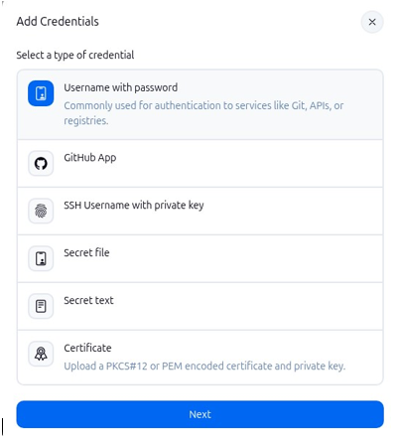
Step 3: now open the terminal and type the command cd MyMavenApp to enter the folder and create a Jenkinsfile .Paste the code in the Jenkinsfile
pipeline {
agent any // Use any available agent
tools {
maven 'Maven' // Ensure this matches the name configured in Jenkins
}
stages {
stage('Checkout') {
steps {
git branch: 'master', url: 'https://github.com/Samiksha201104/MyMavenApp.git'
}
}
stage('Build') {
steps {
sh 'mvn clean package' // Run Maven build
}
}
stage('Test') {
steps {
sh 'mvn test' // Run unit tests
}
}
stage('Run Application') {
steps {
// Start the JAR application
sh 'java -jar target/MyMavenApp-1.0-SNAPSHOT.jar'
}
}
}
post {
success {
echo 'Build and deployment successful!'
}
failure {
echo 'Build failed!'
}}}
Then commit and push it to GitHub
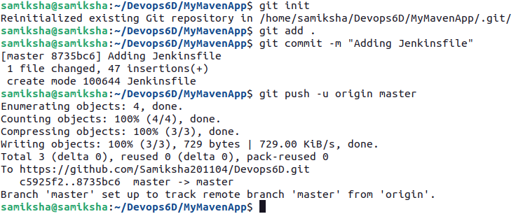
Step 4:Go to Jenkins Dashboard and click on new item , enter the name as MyMavenApp and choose pipeline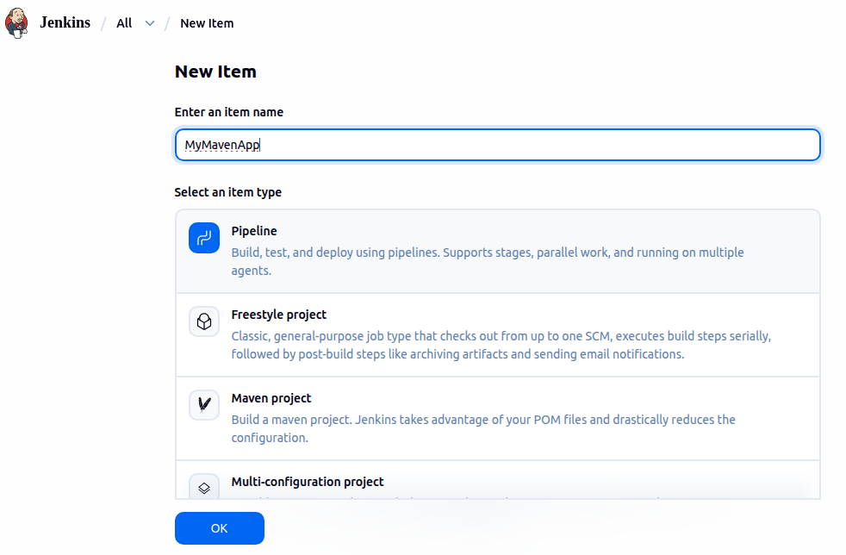

Step 5: in the Jenkins dasboard select MyMavenApp nd select build now and then select full stage view
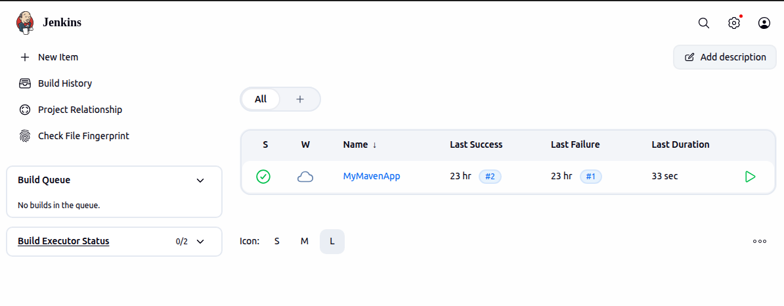
Step 6 : Note the stages that failed and check the error by clicking the stage and selecting logs.
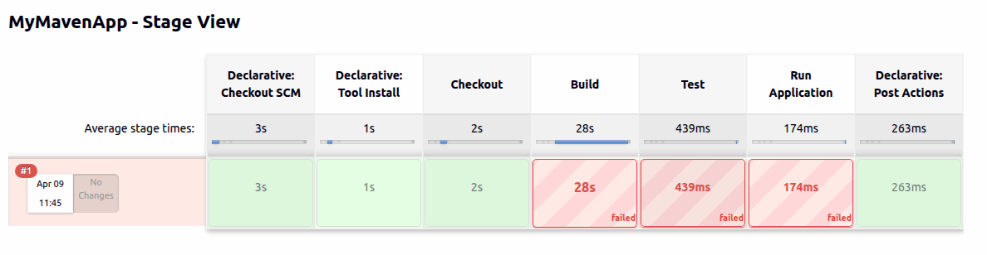
To correct the error open pom.xml and make changes in the code
The original code has the following lines
<source>1.7</source>
<target>1.7</target>
Change this code to
<source>11</source>
<target>11</target>
Push this back to GitHub and build it again on Jenkins

Gradle with Jenkins
Step 1: in the terminal type the code MyGradleApp to enter the folder .
Type the command gedit JenkinsFile to open the Jenkinsfile and paste the code
pipeline {
agent any // Use any available agent

tools {
gradle 'Gradle' // Ensure this matches the name configured in Jenkins
jdk 'JDK'
}
stages {
stage('Checkout') {
steps {
git branch: 'master', url: 'https://github.com/Samiksha201104 /MyGradleApp.git'
}
}
stage('Build') {
steps {
sh 'gradle build' // Run Gradle build
}
}
stage('Test') {
steps {
sh 'gradle test' // Run unit tests
}
}
stage('Run Application') {
steps {
// Start the JAR application
sh 'gradle run'
}}}
post {
success {
echo 'Build and deployment successful!'
}
failure {
echo 'Build failed!'
}}}
Commit and push to GitHub
Step 2: in Jenkins Dasboard click on New Item
Give the name MyGradleApp and select Pipeline
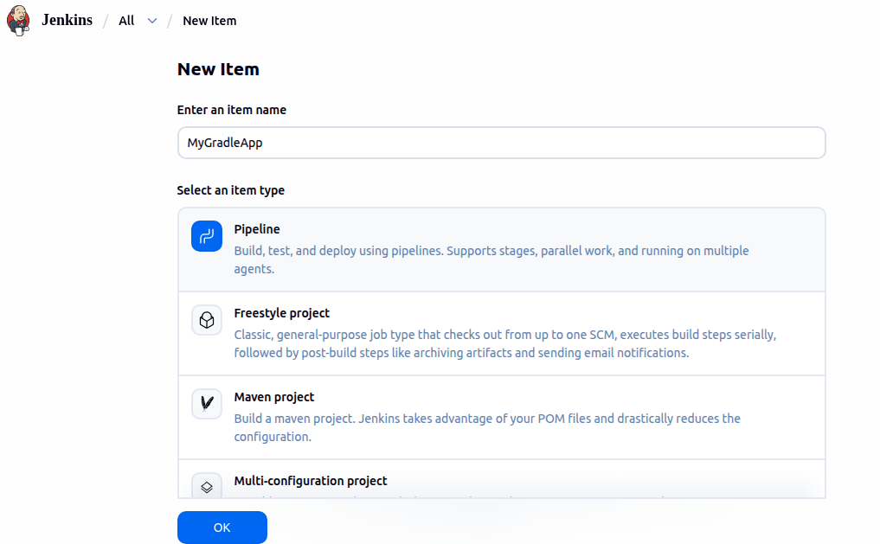
In configure scroll down to Pipeline and choose pipeline script from SCM,give the repository url and choose GitHub Credentials
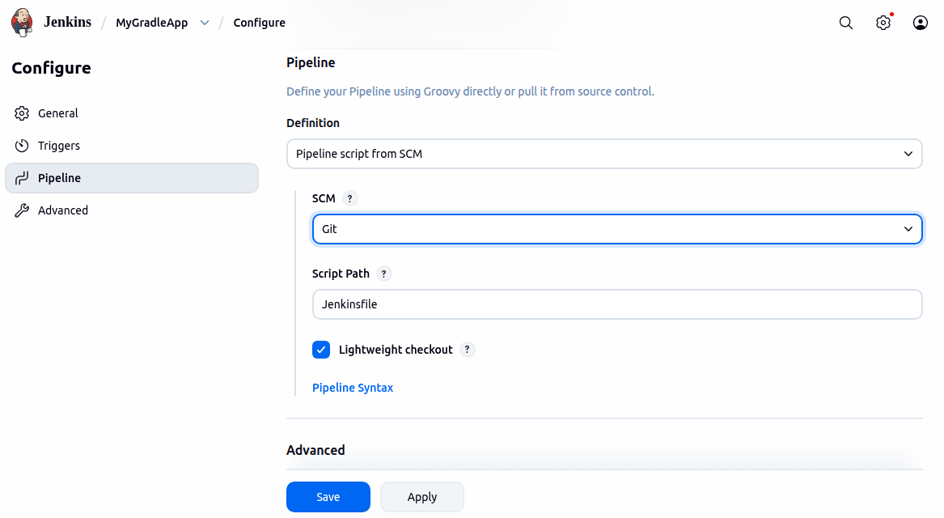
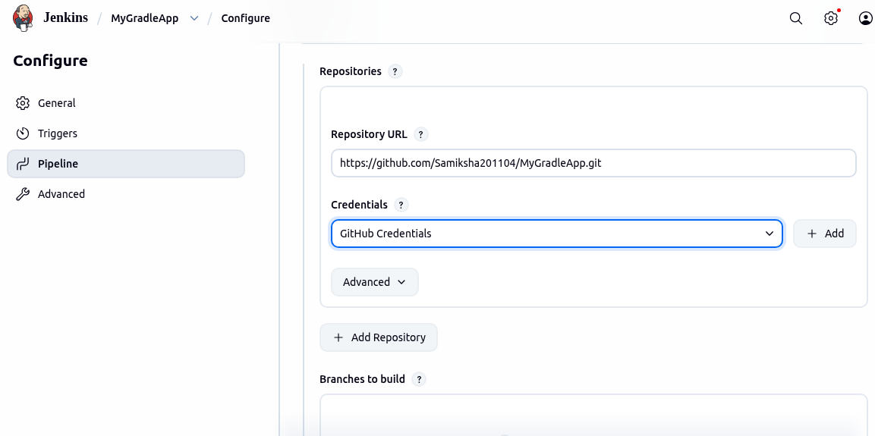
Then click on apply and save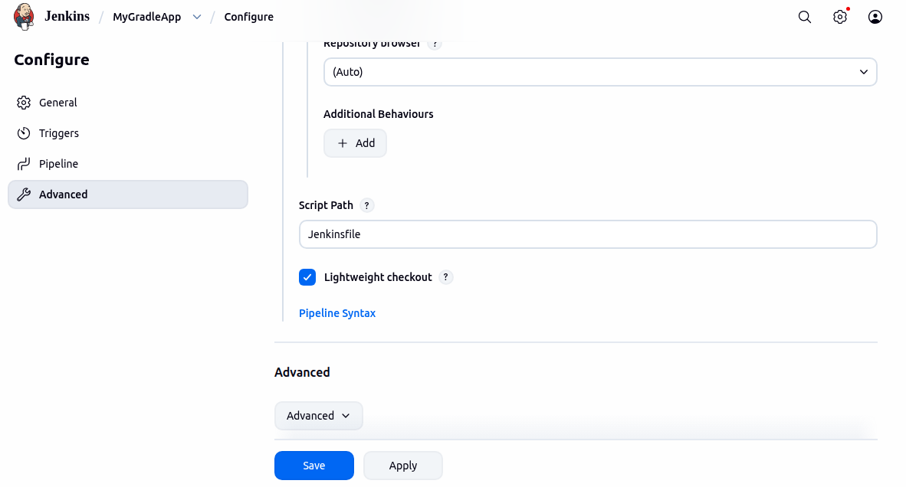
Step 3: go to Jenkins Dasboard select the MyGradleApp pipeline and select Build Now. After build select Full Stage View
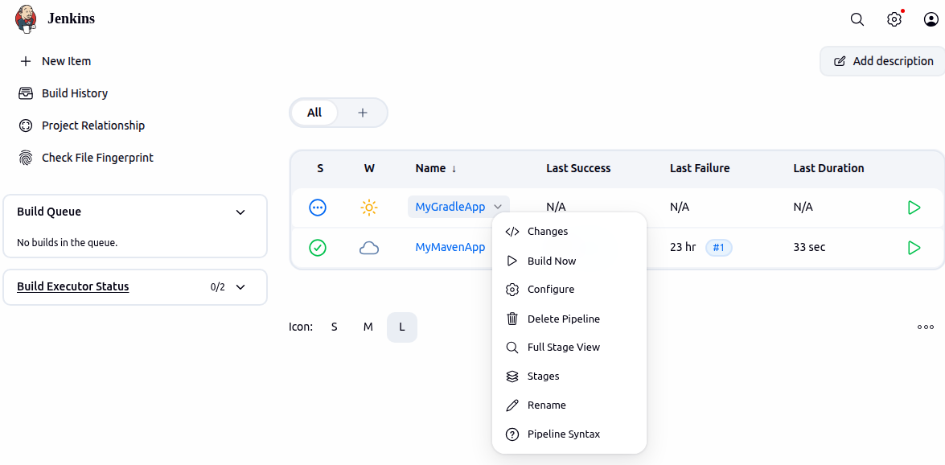
Once the errors are corrected Build again
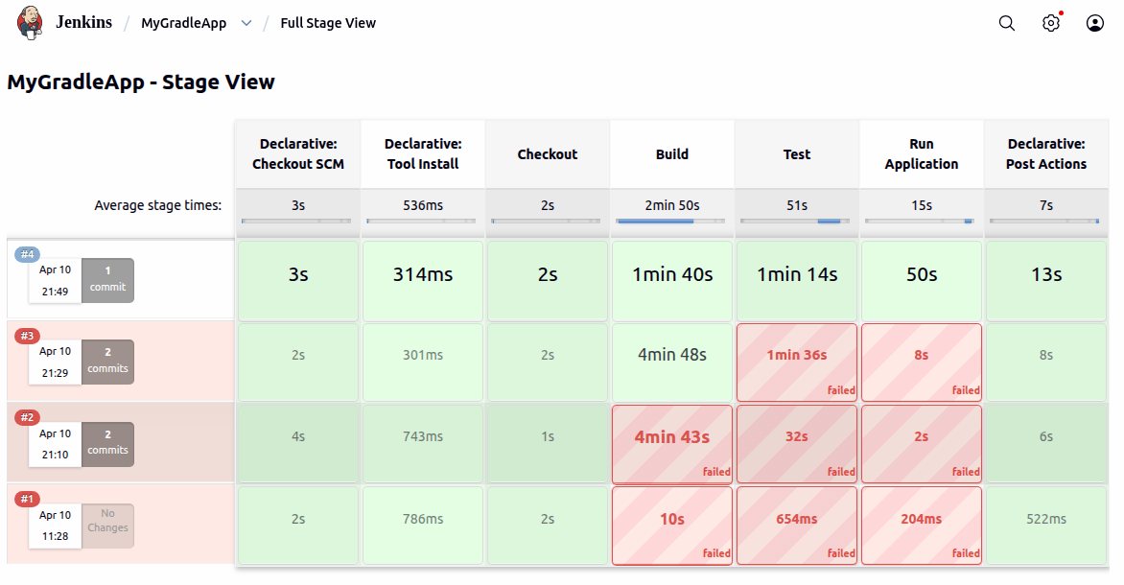

MyMavenPracticeAutomtion
Step 1: now open the terminal and type the command cd MyMavenPracticeAutomationApp to enter the folder and create a Jenkinsfile .Paste the code in the Jenkinsfile
pipeline {
agent any // Use any available agent
tools {
maven 'Maven' // Ensure this matches the name configured in Jenkins
}
stages {
stage('Checkout') {
steps {
git branch: 'master', url: 'https://github.com/Samiksha201104/MyMavenPracticeAutomationApp.git'
}
}
stage('Build') {
steps {
sh 'mvn clean package' // Run Maven build
}
}
stage('Test') {
steps {
sh 'mvn test' // Run unit tests
}
}
stage('Run Application') {
steps {
// Start the JAR application
sh 'java -jar target/MyMavenApp-1.0-SNAPSHOT.jar'
}
}
}
post {
success {
echo 'Build and deployment successful!'
}
failure {
echo 'Build failed!'
}}}
Then commit and push it to GitHub
Step 2:in the Jenkins Dashboard click on new item type the name of the item and select Pipeline
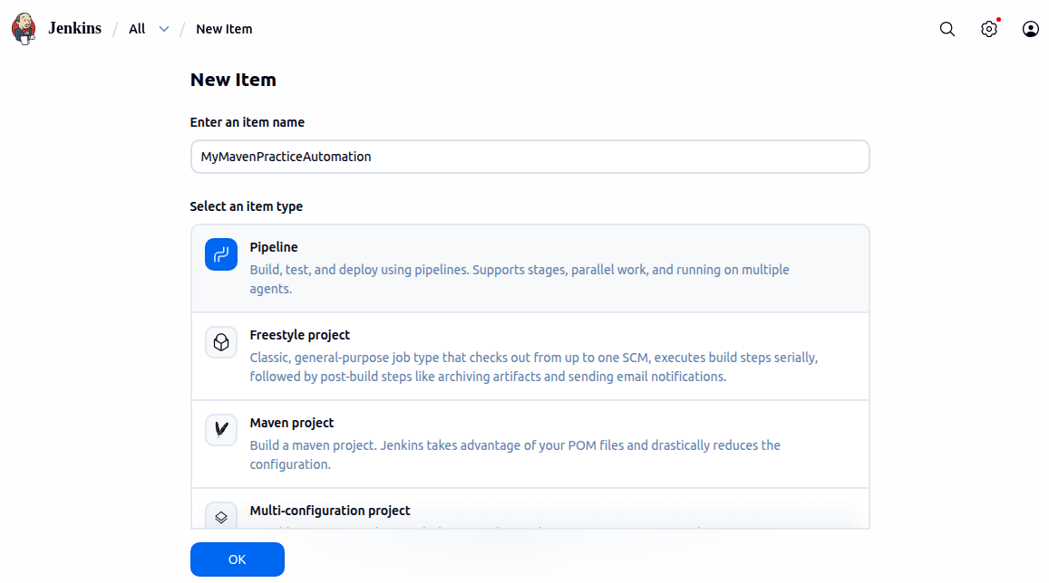
In configure scroll down to Pipeline and choose pipeline script from SCM,give the repository url and choose GitHub Credentials
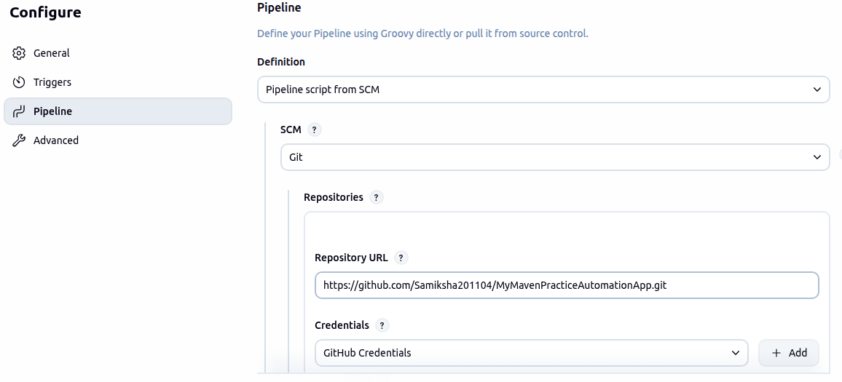
Step 3 : in the Dashboard click on the MyMavenPracticeAutomationApp item and select Build Now and then Full Stage view

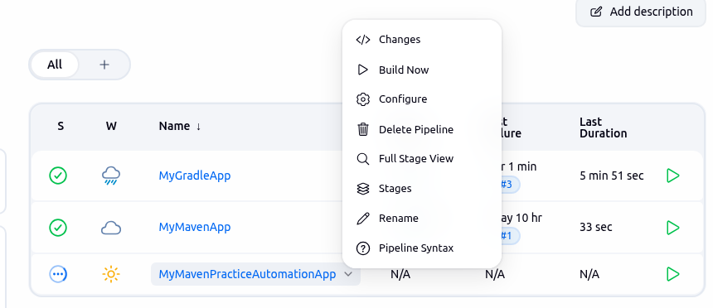
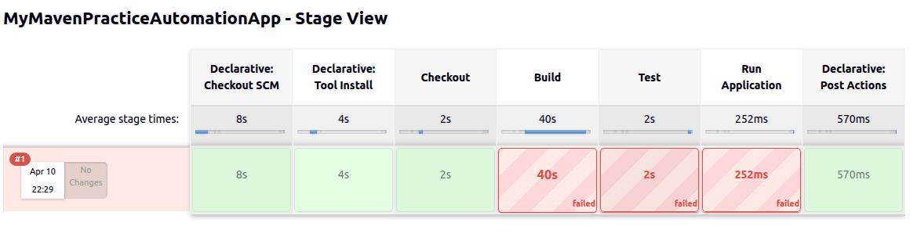
To correct the errors change the code in the pom.xml
<source>17</source>
<target>17</target>

<source>1.7</source>
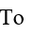
<target>1.7</target>

Save and Build again in Jenkins

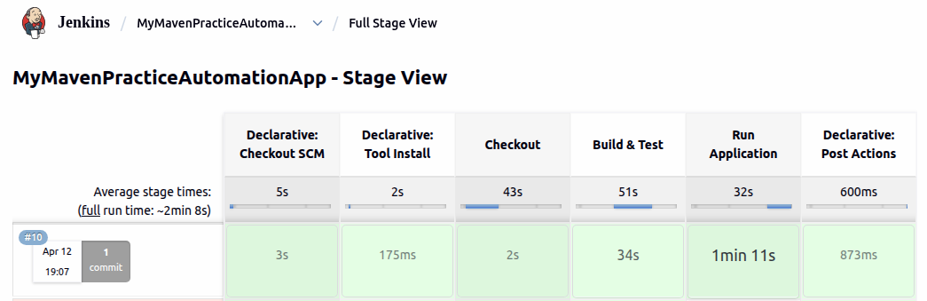
MyMavenExerciseAutomationApp
Step 1: now open the terminal and type the command cd MyMavenExerciseAutomationApp to enter the folder and create a Jenkinsfile .Paste the code in the Jenkinsfile
pipeline {
agent any // Use any available agent
tools {
maven 'Maven' // Ensure this matches the name configured in Jenkins
}
stages {
stage('Checkout') {
steps {
git branch: 'master', url: 'https://github.com/Samiksha201104/MyMavenExerciseAutomationApp.git'
}
}
stage('Build') {
steps {
sh 'mvn clean package' // Run Maven build
}
}
stage('Test') {
steps {
sh 'mvn test' // Run unit tests
}
}
stage('Run Application') {
steps {
// Start the JAR application
sh 'java -jar target/MyMavenApp-1.0-SNAPSHOT.jar'
}
}
}
post {
success {
echo 'Build and deployment successful!'
}
failure {
echo 'Build failed!'
}}}
Then commit and push it to GitHub
Step 2:in the Jenkins Dashboard click on new item type the name of the item and select Pipeline

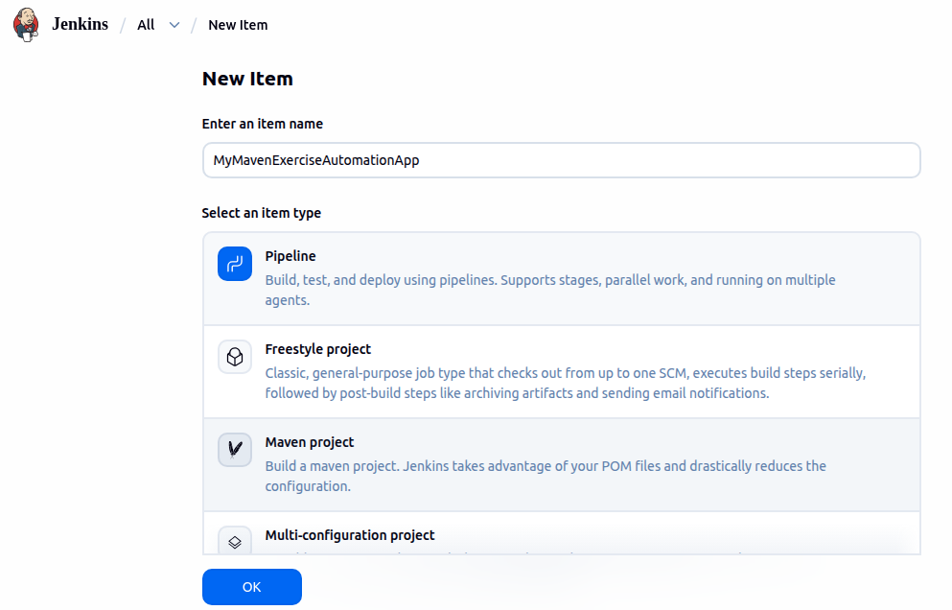
In configure scroll down to Pipeline and choose pipeline script from SCM,give the repository url and choose GitHub Credentials

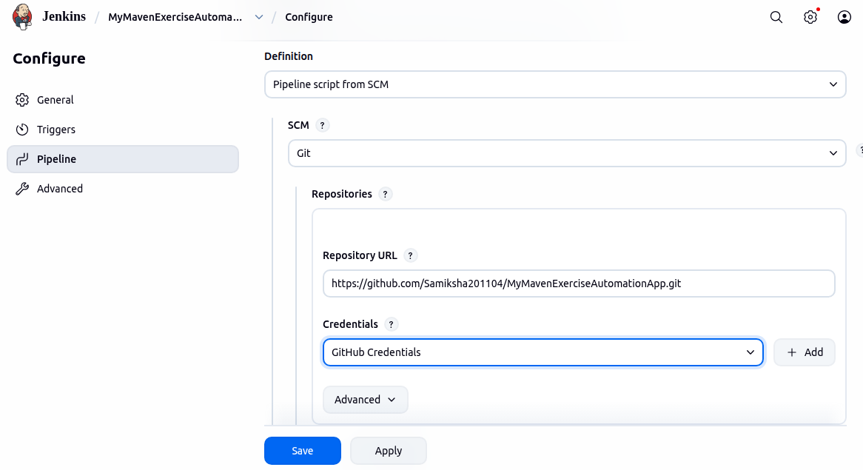
Step 3 : in the Dashboard click on the MyMavenExerciseAutomationApp item and select Build Now and then Full Stage view

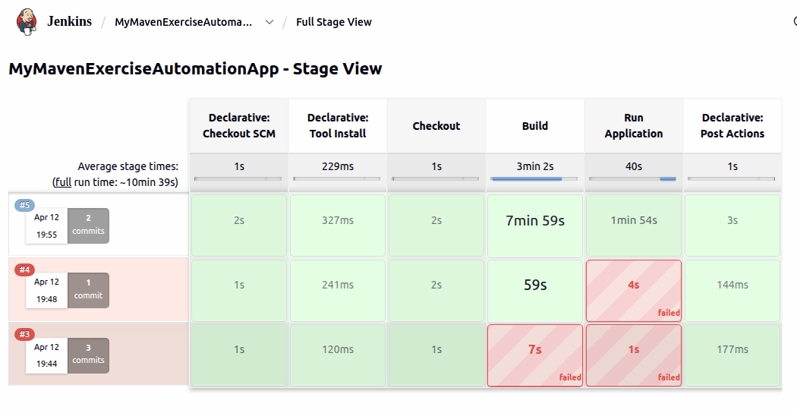

MyMavenGuavaApp
Step 1: now open the terminal and type the command cd MyMavenGuavaApp to enter the folder and create a Jenkinsfile .Paste the code in the Jenkinsfile
pipeline {
agent any // Use any available agent
tools {
maven 'Maven' // Ensure this matches the name configured in Jenkins
}
stages {
stage('Checkout') {
steps {
git branch: 'master', url: 'https://github.com/Samiksha201104/MyMavenGuavaApp.git'
}
}
stage('Build') {
steps {
sh 'mvn clean package' // Run Maven build
}
}
stage('Test') {
steps {
sh 'mvn test' // Run unit tests
}
}
stage('Run Application') {
steps {
// Start the JAR application
sh 'java -jar target/MyMavenGuavaApp-1.0-SNAPSHOT.jar'
}
}
}
post {
success {
echo 'Build and deployment successful!'
}
failure {
echo 'Build failed!'
}}}
Then commit and push it to GitHub
Step 2:in the Jenkins Dashboard click on new item type the name of the item and select Pipeline

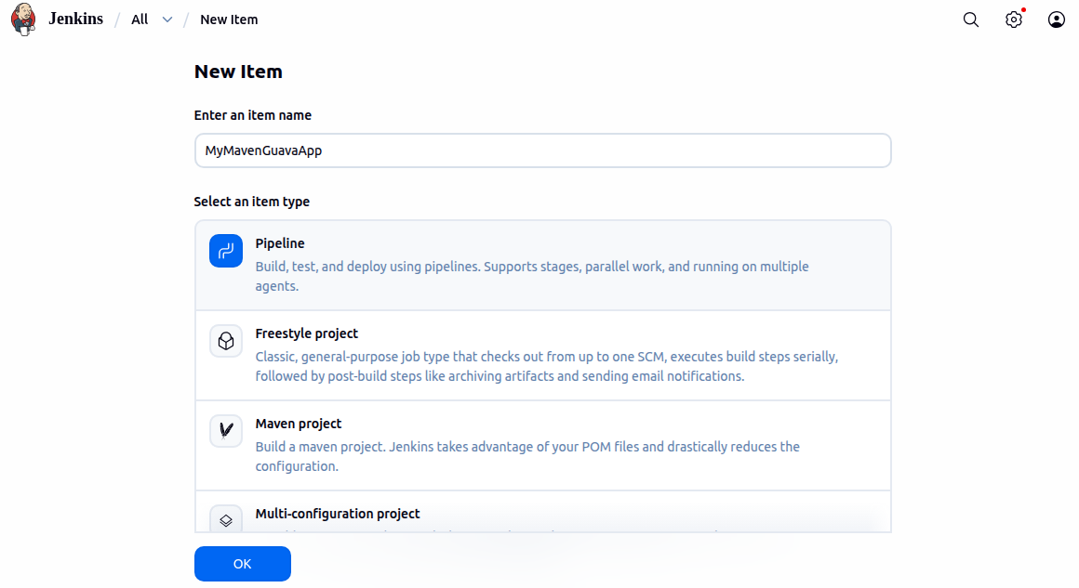
In configure scroll down to Pipeline and choose pipeline script from SCM,give the repository url and choose GitHub Credentials
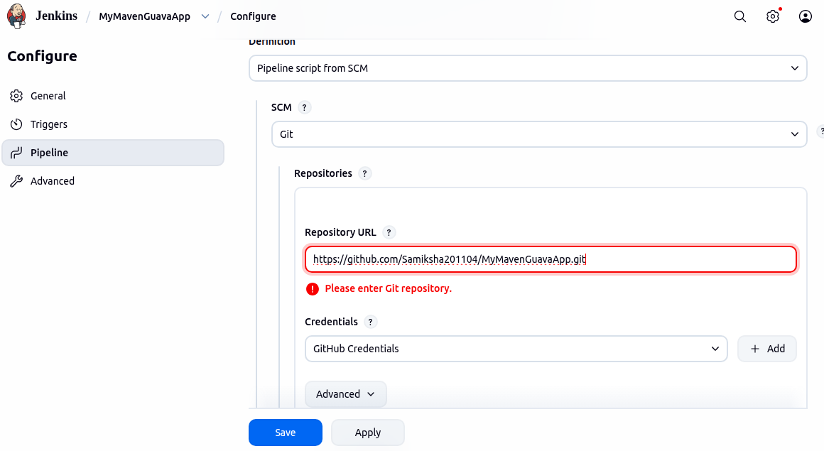
Step 3 : in the Dashboard click on the MyMavenGuavaApp item and select Build Now and then Full Stage view
Correct the errors and build again on jenkins till all the stages are successful
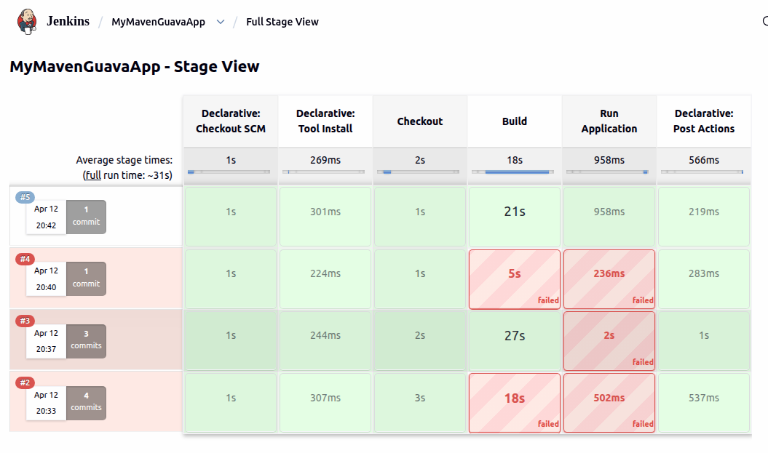
MyMavenToGradle
Step 1: now open the terminal and type the command cd MyMavenToGradleApp to enter the folder and create a Jenkinsfile .Paste the code in the Jenkinsfile
pipeline {
agent any // Use any available agent
tools {
maven 'Maven' // Ensure this matches the name configured in Jenkins
}
stages {
stage('Checkout') {
steps {
git branch: 'master', url: 'https://github.com/Samiksha201104/MyMavenGradleApp.git'
}
}
stage('Build') {
steps {
sh 'mvn clean package' // Run Maven build
}
}
stage('Test') {
steps {
sh 'mvn test' // Run unit tests
}
}
stage('Run Application') {
steps {
// Start the JAR application
sh 'java -jar target/MyMavenGradleApp-1.0-SNAPSHOT.jar'
}
}
}
post {
success {
echo 'Build and deployment successful!'
}
failure {
echo 'Build failed!'
}}}
Then commit and push it to GitHub
Step 2:in the Jenkins Dashboard click on new item type the name of the item and select Pipeline
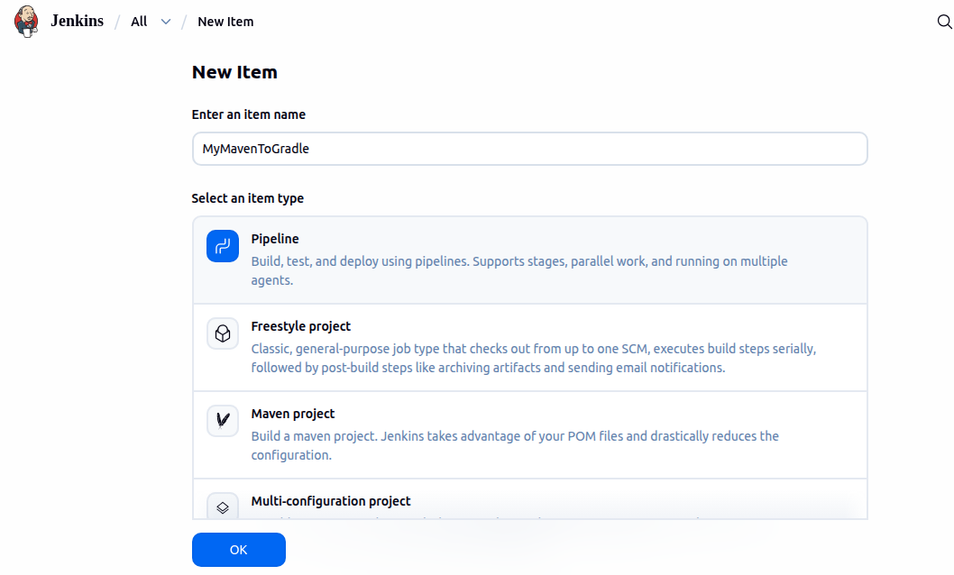

In configure scroll down to Pipeline and choose pipeline script from SCM,give the repository url and choose GitHub Credentials
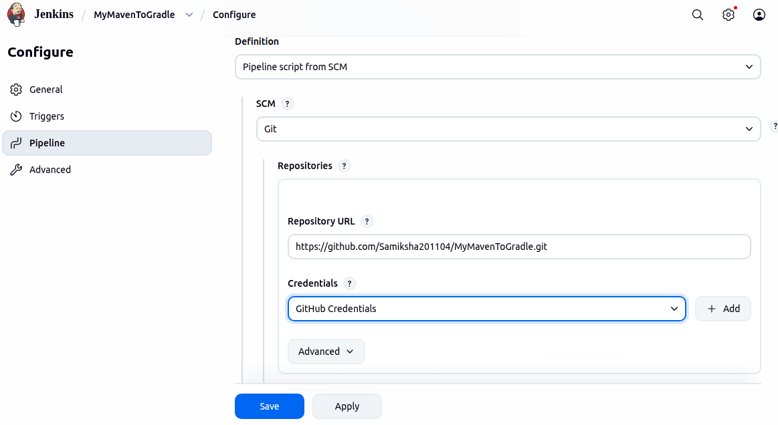
Step 3 : in the Dashboard click on the MyMavenToGradleApp item and select Build Now and then Full Stage view
Correct the errors and build again on jenkins till all the stages are successful
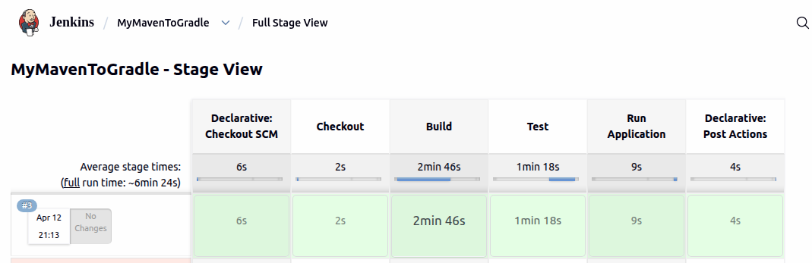

MyMavenSeleniumApp
Step 1: now open the terminal and type the command cd MyMavenSeleniumApp to enter the folder and create a Jenkinsfile .Paste the code in the Jenkinsfile
pipeline {
agent any // Use any available agent
tools {
maven 'Maven' // Ensure this matches the name configured in Jenkins
}
stages {
stage('Checkout') {
steps {
git branch: 'master', url: 'https://github.com/Samiksha201104/MyMavenSeleniumApp.git'
}
}
stage('Build') {
steps {
sh 'mvn clean package' // Run Maven build
}
}
stage('Test') {
steps {
sh 'mvn test' // Run unit tests
}
}
stage('Run Application') {
steps {
// Start the JAR application
sh 'java -jar target/MyMavenSeleniumApp-1.0-SNAPSHOT.jar'
}
}
}
post {
success {
echo 'Build and deployment successful!'
}
failure {
echo 'Build failed!'
}}}
Then commit and push it to GitHub
Step 2:in the Jenkins Dashboard click on new item type the name of the item and select Pipeline 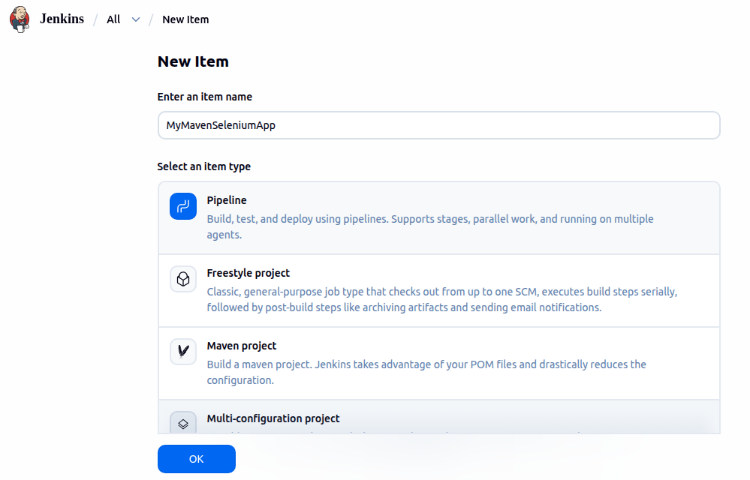

In configure scroll down to Pipeline and choose pipeline script from SCM,give the repository url and choose GitHub Credentials 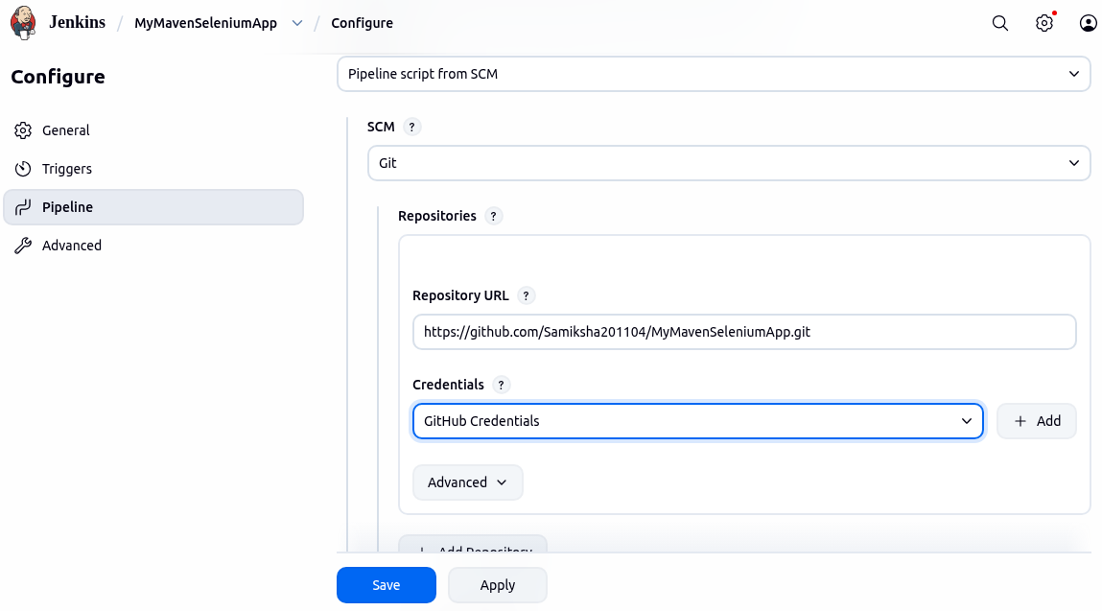

Step 3 : in the Dashboard click on the MyMavenToGradleApp item and select Build Now and then Full Stage view
Correct the errors and build again on jenkins till all the stages are successful
